10. ReactJS-HOL

**10. ReactJS-HOL**

## **Objectives**

* Define JSX
* Explain about ECMA Script
* Explain React.createElement()
* Explain how to create React nodes with JSX
* Define how to render JSX to DOM
* Explain how to use JavaScript expressions in JSX
* Explain how to use inline CSS in JSX

In this hands-on lab, you will learn how to:

* Use JSX syntax in React applications
* Use inline CSS in JSX

## **Prerequisites**

The following is required to complete this hands-on lab:

* Node.js
* NPM
* Visual Studio Code

## **Notes**

Estimated time to complete this lab: **60 minutes.**

Create a React Application named “officespacerentalapp” which uses React JSX to create elements, attributes and renders DOM to display the page.

Create an element to display the heading of the page.

Attribute to display the image of the office space

Create an object of office to display the details like Name, Rent and Address.

Create a list of Object and loop through the office space item to display more data.

To apply Css, Display the color of the Rent in Red if it’s below 60000 and in Green if it’s above 60000.

Output:

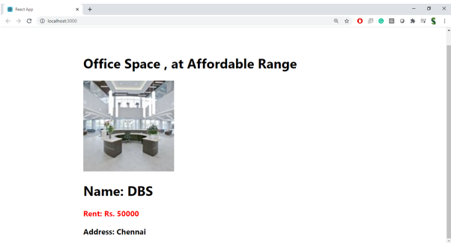

**Hint:**

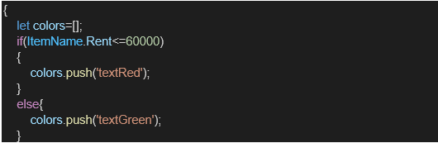

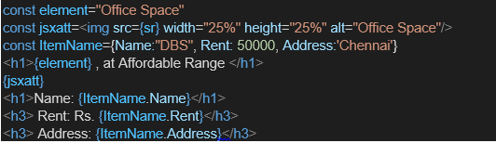

Code:

import React from 'react';

// --- Data for the Application ---

// As per the requirements, we create a list of office space objects.

// Each object contains details like name, rent, address, and an image URL.

const officeSpaces = [

{

name: 'DBS',

rent: 50000,

address: 'Chennai',

imageUrl: 'https://placehold.co/600x400/E7E5E4/5D5C61?text=Modern+Office',

},

{

name: 'WeWork',

rent: 75000,

address: 'Mumbai',

imageUrl: 'https://placehold.co/600x400/D4E09B/4E6E58?text=Creative+Hub',

},

{

name: 'Regus',

rent: 58000,

address: 'Bangalore',

imageUrl: 'https://placehold.co/600x400/A3B18A/344E41?text=Corporate+Suite',

},

{

name: 'Innov8',

rent: 65000,

address: 'Delhi',

imageUrl: 'https://placehold.co/600x400/9B7E46/3A3226?text=Startup+Zone',

},

];

// --- Office Space Card Component ---

// This component is responsible for displaying a single office space.

// It receives the office data as a prop.

function OfficeSpaceCard({ space }) {

// Requirement: Apply conditional inline CSS for the rent.

// We create a style object. The color property is determined by the rent value.

const rentStyle = {

color: space.rent <= 60000 ? 'red' : 'green',

fontWeight: 'bold',

fontSize: '1.125rem', // Equivalent to text-lg

};

return (

// Using Tailwind CSS for a clean, card-based layout.

<div className="bg-white rounded-lg shadow-md overflow-hidden border border-gray-200">

{/* Requirement: Attribute to display the image of the office space */}

<img

src={space.imageUrl}

alt={`Office space at ${space.name}`}

className="w-full h-48 object-cover"

// Add a fallback for the image in case the link is broken

onError={(e) => { e.target.onerror = null; e.target.src='https://placehold.co/600x400/ccc/FFF?text=Image+Not+Found'; }}

/>

<div className="p-6">

{/* Requirement: Display the details from the object */}

<h2 className="text-2xl font-bold text-gray-800 mb-2">Name: {space.name}</h2>

<p style={rentStyle}>Rent: Rs. {space.rent.toLocaleString()}</p>

<p className="text-md text-gray-600 mt-1">Address: {space.address}</p>

</div>

</div>

);

}

// --- Main App Component ---

export default function App() {

// This is the main component that renders the entire page.

return (

<div className="bg-gray-50 min-h-screen font-sans p-4 sm:p-8">

<div className="max-w-4xl mx-auto">

{/* Requirement: Create an element to display the heading of the page. */}

<h1 className="text-4xl font-extrabold text-center text-gray-800 mb-8">

Office Space, at Affordable Range

</h1>

{/* Requirement: Create a list of Objects and loop through them.

We use the .map() function to iterate over the `officeSpaces` array.

For each `space` object in the array, we render an `OfficeSpaceCard` component.

We pass the `space` object as a prop and use the address as a unique `key`.

*/}

<div className="grid grid-cols-1 md:grid-cols-2 gap-8">

{officeSpaces.map((space) => (

<OfficeSpaceCard key={space.name + space.address} space={space} />

))}

</div>

</div>

<footer className="text-center mt-12 text-gray-500">

<p>Office Space Rental App</p>

</footer>

</div>

);

}

